Adam Chlebek

Lab 2

Part 1

1a.

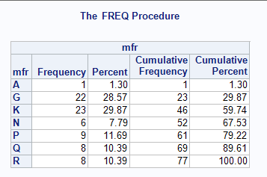

1b. A normal type variable does not have a set order with the options whereas an ordinary variable has an ordering of them. The manufacturers do not have a set order between them whereas the grade scale has an order. For ordinary variables, the cumulative frequency would make more sense since the variables have more of a meaning.

1c.

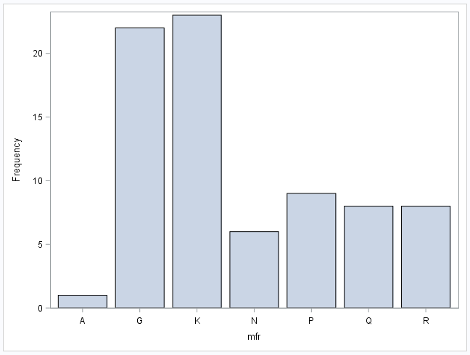

2a.

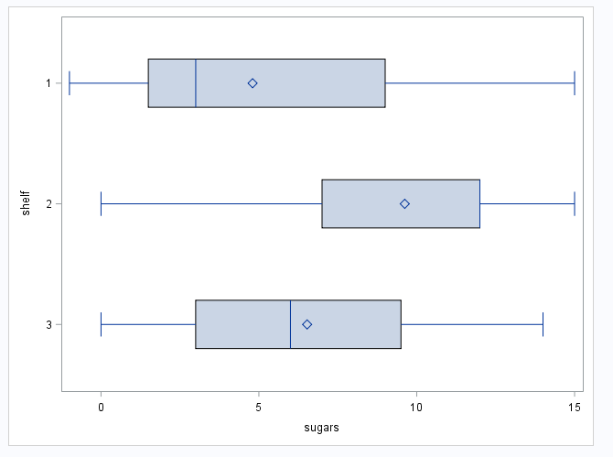

2b.

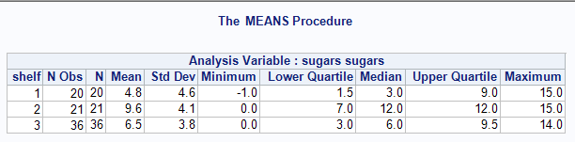

2c. The median and the Upper Quartile have the same value so the line is there, it just overlaps another one.

2d. ✓

3ai.

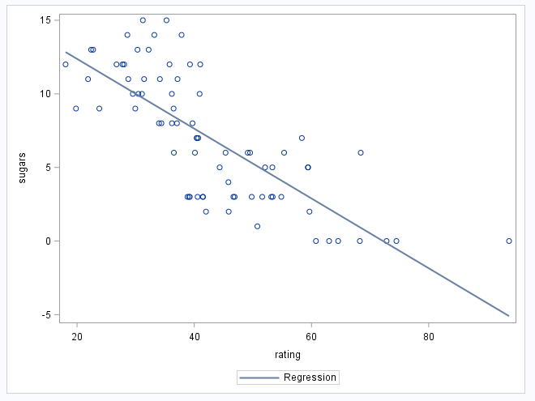  
3aii.

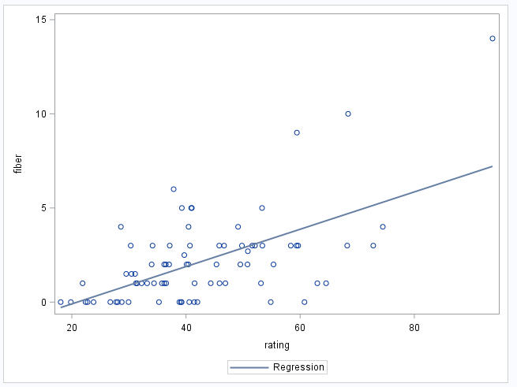

3b.

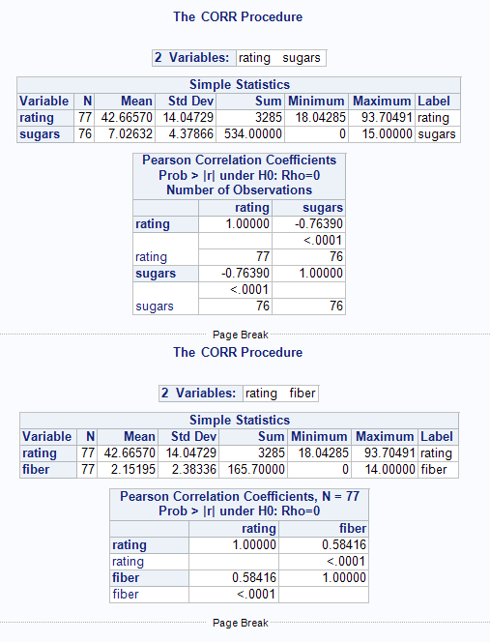

3c. The strength of sugars and rating correlation is stronger because it is closer to 1. However, the correlation value is negative because the line’s slope is negative.

3d.

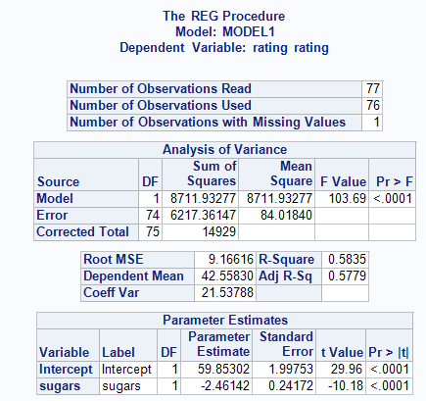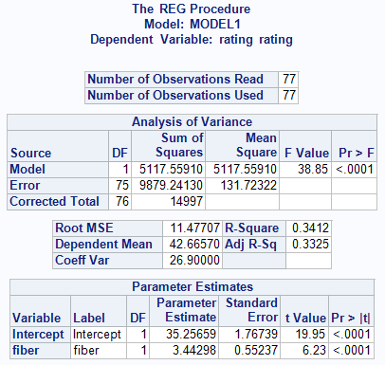

3di. Rating(hat) = 59.8 + -2.5 * sugar

3dii. Rating(hat) = 35.3 + 3.4 * fiber

3e.

3ei. As sugar increases by 1g, the rating decreases by **-2.5** units on average.

3eii. As fiber increases by 1g, the rating increases by **3.4** units on average.

Part 2

1.

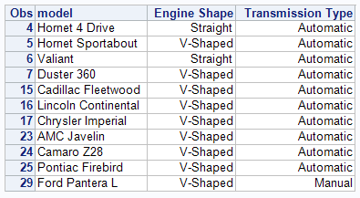

2a.

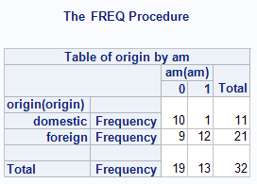

2bi. 65.63% of the cars are foreign. (red)

2bii. 40.63% of cars are manual transmission (blue)

2biii. 90.91% of domestic cars are automatic transmission (pink)

2biv. 92.31% of manual cars are foreign (green)

2c.

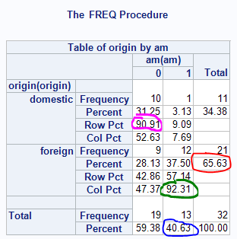

2d.

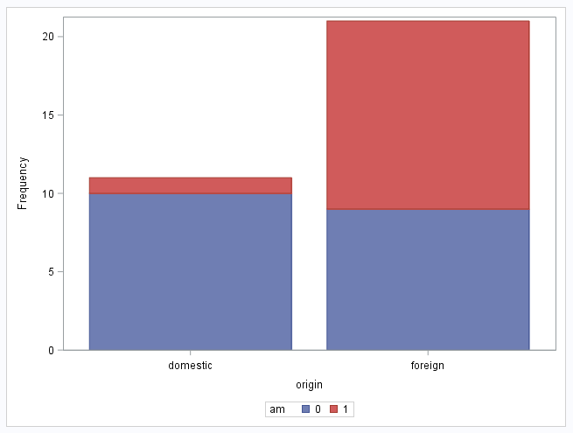

3a.

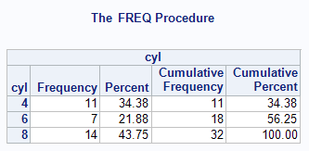

3b.

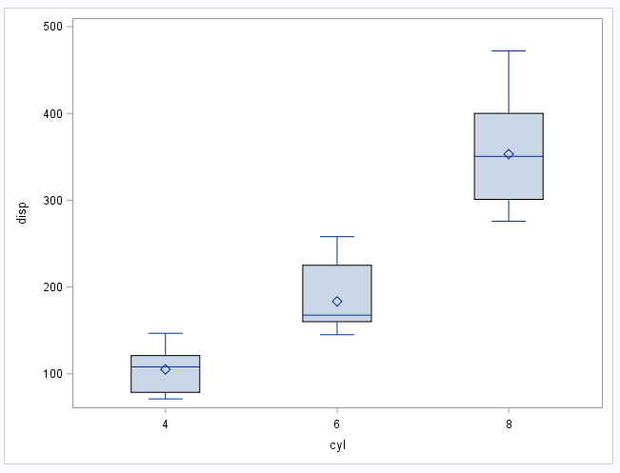

3c. Right when the engine displacement hits a threshold, the amount of cylinders that are needed will be increased. Since the volume is higher, this means cylinder count will have to be increased.

3d.

